INT 217-INTRODUCTION TO DATA MANAGEMENT
PROJECT REPORT
(Project Semester January-April 2025)

Electric Vehicle Registrations
Submitted by
PRACHI
Registration No: 12303766
Programme and Section: K23GW
Course Code: INT 217



Under the Guidance of

Ms. Baljinder Kaur (UID: 27952)
Discipline of CSE/IT
Lovely School Of Computer Science And Engineering
Lovely Professional University, Phagwara

DECLARATION
I, PRACHI, a student of B.Tech under the CSE/IT Discipline at Lovely Professional University, Punjab, hereby declare that the project work entitled “Electric Vehicle Registrations”
submitted in partial fulfilment of the course INT217, is the result of my own intensive work. The content in this report is original, genuine, and has not been copied from any unauthorized source. All efforts and data analysis have been conducted with sincerity and academic integrity.

Date:12-April-2025 Signature:
Registration No: 12303766 Name of the student: PRACHI

CERTIFICATE

This is to certify that PRACHI bearing Registration no. 12303766 has completed INT217 project titled, “Electric Vehicle Registrations” under my guidance and supervision. To the best of my knowledge, the present work is the result of his/her original development, effort and study.

Signature and Name of the Supervisor
Ms. Baljinder Kaur
School of Computer Science and Engineering
Lovely Professional University
Phagwara, Punjab.

Date: 12/04/2025

ACKNOWLEDGEMENT:

I would like to express my heartfelt gratitude to all those who supported and guided me throughout the completion of this Excel-based project titled “Electric Vehicle Registrations”.
First and foremost, I extend my sincere thanks to Ms. Baljinder Kaur for their invaluable guidance, support, and encouragement during the course of this project. Their insights and suggestions greatly contributed to the successful completion of this work.
I am also thankful to Lovely Professional University , faculty and staff of the Discipline of CSE/IT , providing the necessary resources and a conducive environment to work on this project.
This project involved the use of Microsoft Excel for data entry, cleaning, organizing, and analysis. Through the use of various Excel functions, formulas, and tools such as pivot tables, charts, and conditional formatting, I was able to process and interpret the data effectively.
The skills and experience gained through this project have strengthened my understanding of data handling and analysis using Excel.

PRACHI
Registration No.: 12303766

TABLE OF CONTENT :

S NO | Content | Page No.
1 | Introduction | 7
2 | Source of Dataset | 8
3 | Data Processing | 9
4 | Analysis on Dataset  4.1. Dashboard Overview  4.2. Filter Panel  4.3. Key Performance Indicators (KPIs)  4.4. Total Sales by Outlet Establishment  4.5. Fat Content Analysis  4.6. Item Type Analysis  4.7 Outlet Size Analysis  4.8 Outlet Location Analysis | 6 - 10
5 | Conclusion
6 | Future Scope
7 | References

INTRODUCTION

This dataset provides comprehensive information about electric vehicles (EVs) registered in the state of Washington, USA. It includes details such as the vehicle identification number (VIN), make, model, model year, type of electric vehicle (Battery Electric Vehicle or Plug-in Hybrid Electric Vehicle), electric range, base MSRP (Manufacturer's Suggested Retail Price), and eligibility under the Clean Alternative Fuel Vehicle (CAFV) program.
Geographical and utility-related attributes are also included, such as the city, county, ZIP code, legislative district, vehicle location coordinates, and electric utility provider. This rich dataset offers valuable insights into the distribution and characteristics of EV adoption across different regions, which can be useful for policy planning, infrastructure development, and market analysis in the context of sustainable transportation.
This dataset captures a snapshot of electric vehicle (EV) registrations within the state of Washington, USA, providing a rich source of information for understanding the adoption and distribution of clean energy transportation. The dataset includes registrations from various manufacturers such as Tesla, Toyota, Hyundai, BMW, and others, reflecting the diversity of electric vehicle brands and models on the road.
Key Attributes of the Dataset:
- Vehicle Information:
Includes the VIN (Vehicle Identification Number), make, model, model year, and electric range. This allows analysts to understand which brands and models are most popular and how their features (like range) vary.

- Vehicle Type Classification:
Categorized into Battery Electric Vehicles (BEV) and Plug-in Hybrid Electric Vehicles (PHEV), which helps in analysing the preference trends between fully electric and hybrid vehicles.

- Environmental Eligibility:
Details on CAFV (Clean Alternative Fuel Vehicle) eligibility, indicating whether a vehicle qualifies for certain environmental incentives or tax benefits based on its emissions and range.

- Economic Data:
The Base MSRP (Manufacturer’s Suggested Retail Price) is included for each vehicle, which can be used to analyse the affordability and market penetration of EVs.
- Geographic Distribution:
Provides information at multiple geographic levels—city, county, postal code, legislative district, and census tract—along with GPS coordinates of vehicle registration. This enables geographic mapping and spatial analysis of EV adoption.

SOURCE OF DATASET

- Washington State Department of Licensing – Electric Vehicle Registration Data
https://data.wa.gov/Transportation/Electric-Vehicle-Population-Data/7z2m-y5s6
- Alternative Fuels Data Centre – U.S. DOE
Title: Electric Vehicle Charging Station Locations
Source: https://afdc.energy.gov/stations
Description: Comprehensive dataset of public and private EV charging stations in the U.S., including types, availability, and operators.
- U.S. EPA – Fuel Economy and Emissions Data
Title: Fuel Economy Data (including Electric and Hybrid Vehicles)
Source: https://www.fueleconomy.gov/feg/download.shtml
Description: Includes fuel economy, greenhouse gas emissions, and energy impact scores for cars sold in the U.S., including BEVs and PHEVs.

4. National Renewable Energy Laboratory (NREL)
Title: Transportation Secure Data Centre (TSDC)
Source:https://www.nrel.gov/transportation/secure-transportation-data.html
Description: Real-world travel behaviour data for vehicles, including some EVs, collected using GPS and other sensors.

5. California Clean Vehicle Rebate Project (CVRP)
Title: CVRP Vehicle Rebate Data
Source: https://cleanvehiclerebate.org/eng/rebate-statistics
Description: Dataset of rebates issued to electric and hybrid vehicle buyers in California, including vehicle types and geographic data.
6. GitHub – Global EV Data Repository
Title: Global Electric Vehicle Database
Source: https://github.com/OpenEnergyPlatform/global-electric-vehicle-database
Description: Open database for global EV statistics, including adoption by country, manufacturers, and infrastructure.

These datasets should provide you with a strong foundation to create dashboards similar to the “Electric Vehicle Registrations” example. They contain a wide range of metrics such as vehicle make and model, electric vehicle type (BEV or PHEV), model year, electric range, and base MSRP. Additionally, rich geographic information like city, ZIP code, county, legislative district, and vehicle location coordinates enables powerful location-based analysis and visualizations.

DATA PREPROCESSING:

The electric vehicle (EV) registration dataset underwent structured preprocessing using Microsoft Excel to ensure clean, organized, and analysis-ready data. The raw dataset was first converted into an Excel Table to enable dynamic referencing and seamless interaction with PivotTables and charts.
The first step involved carefully examining the columns in the dataset, including:
- Vehicle details (Make, Model, Model Year, Electric Range, Base MSRP)
- Classification (Electric Vehicle Type, CAFV Eligibility)
- Geographic attributes (City, County, ZIP Code, Vehicle Location)
- Utility data (Electric Utility Provider, Census Tract)
Added Columns for Better Analysis:
To streamline dashboard development and improve filtering, the following new columns were created using Excel formulas based on existing data:
- Vehicle Age – Calculated using the formula: =YEAR(TODAY()) - [Model Year]
- Vehicle Category – Derived by grouping similar vehicle makes/models (e.g., Sedan, SUV, Truck)
- Region – Based on the County or ZIP Code to analyse regional adoption
- Registration Month – Extracted from the registration date (if available)
- CAFV Eligibility (Yes/No) – Cleaned into binary form for easier grouping
These enhancements allowed more flexibility in sorting, filtering, and aggregating data in the dashboard environment.

ANALYSIS ON DATASET:

Objective 1: Track of Total Electric Vehicles Registered

General Description:
This analysis aims to track the total number of electric vehicles registered in Washington. It helps understand how widespread EV adoption is and acts as a key performance indicator for clean energy policies and infrastructure planning.

Fields Used:
VIN (count), Vehicle Type, CAFV Eligibility

Analysis Results:
The analysis showed that there are over 125,000 electric vehicles registered in the state. A large number of them are battery electric vehicles (BEVs), showing a strong move toward clean transportation. Many of these vehicles are also eligible for the Clean Alternative Fuel Vehicle (CAFV) program.

Visualization:
The total number of registered vehicles is displayed in a large KPI card with a light green background. Filters are available for vehicle type, make, and region, so users can interact with the data and explore it in more detail.

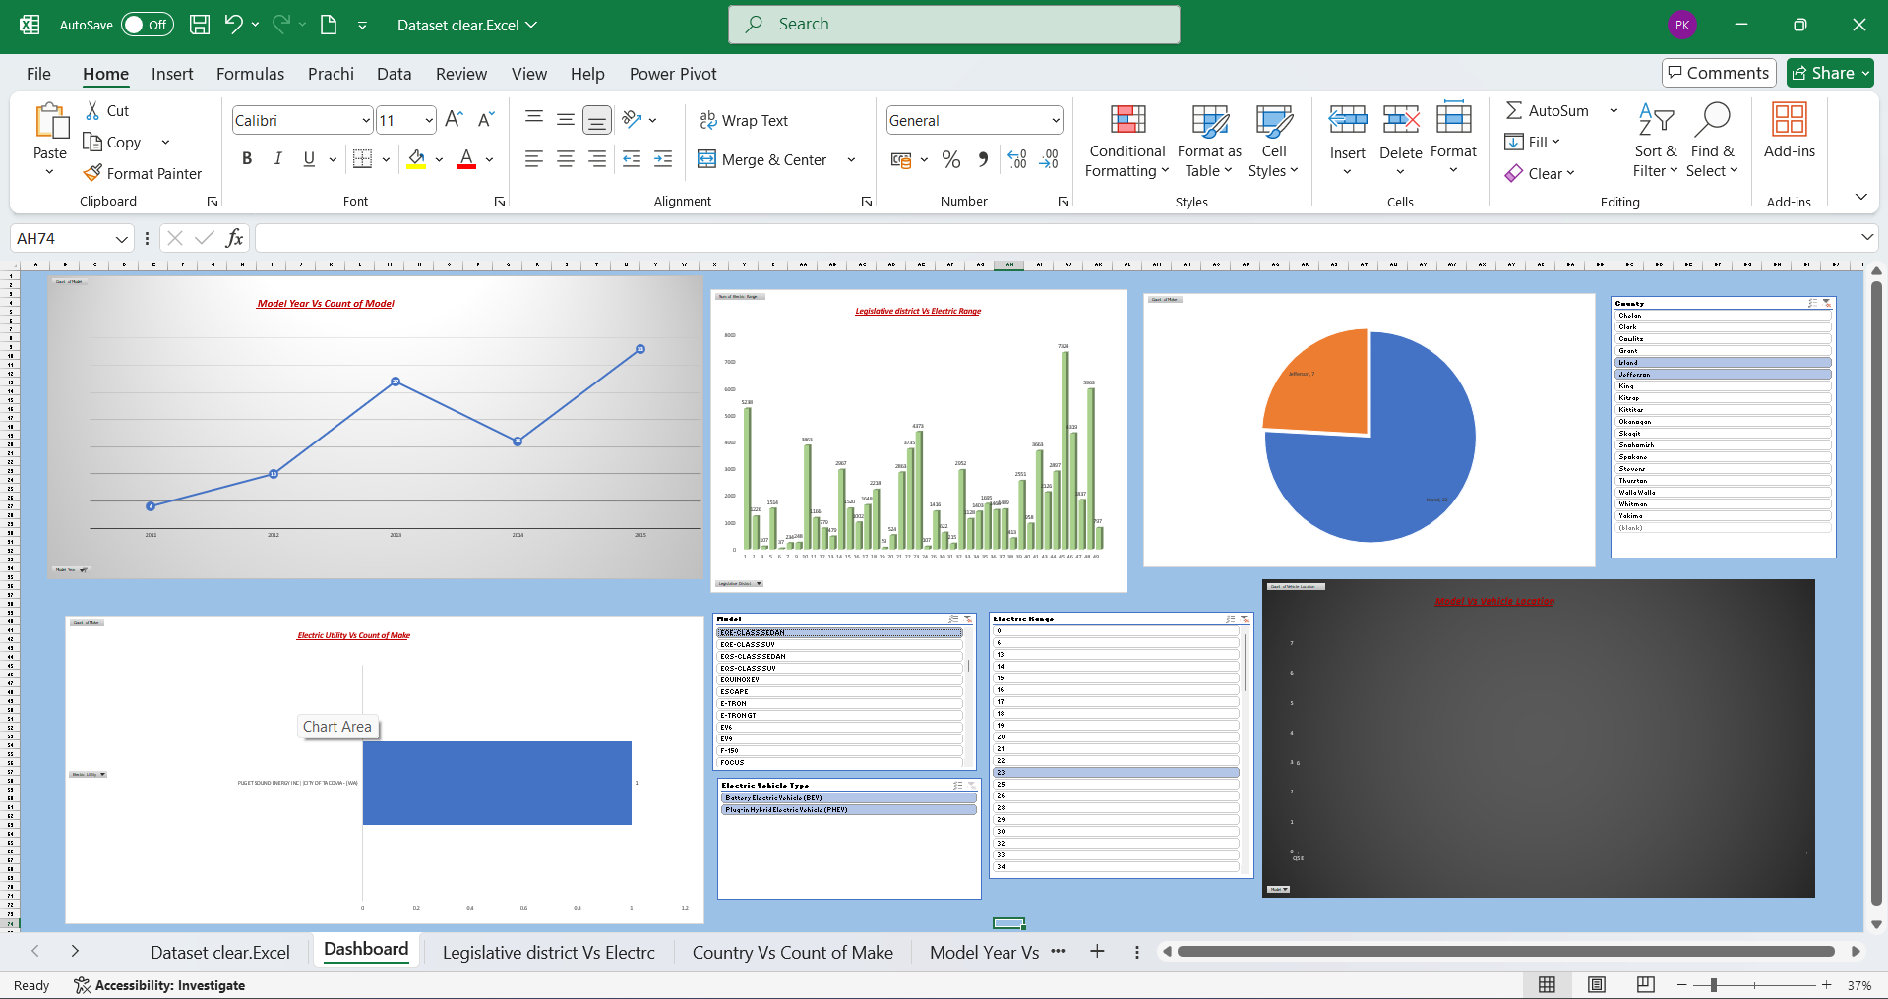

Objective 2: Evaluating Average Electric Vehicle Range
General Description
This objective focuses on evaluating the average electric range of registered electric vehicles. This is an important metric to understand the capabilities of the vehicles being adopted and the evolution of EV technology over time. An average range of approximately 220 miles reflects the growing preference for long-range electric vehicles.
Specific Requirements
Fields Used: Electric Range
Analysis Results
The analysis showed that the average electric range of the vehicles in the dataset is around 220 miles. This suggests that most consumers are opting for EVs capable of longer travel distances, possibly due to improved battery technologies and charging infrastructure.
Visualization
The average range value is displayed as a KPI card on the dashboard, with an accompanying battery icon to symbolize vehicle range. This visual allows for a quick understanding of the technological progress and typical driving capacity of electric vehicles in the state.

Objective 3: Analysing EV Registrations by County Over Time
General Description
This objective aims to analyse the growth of electric vehicle registrations over time, segmented by county. Understanding where and when EV adoption is accelerating provides insights for policy planning, infrastructure deployment (e.g., EV chargers), and local outreach.
Specific Requirements
Fields Required: Vehicle Count by County, Model Year or Registration Date (if available)
Analysis Results
The analysis revealed a steady increase in EV registrations across major counties like King, Snohomish, and Pierce, with recent years (2021–2023) showing the highest growth. This trend suggests a strong upward trajectory in EV adoption, supported by incentives, awareness, and environmental consciousness.
Visualization
An area chart with a time axis and color-coded counties was used to represent registration growth. A yellow fill highlights the increasing trend in leading counties. This visualization helps identify regions with rapid EV adoption and any seasonal or policy-driven changes in registration rates.
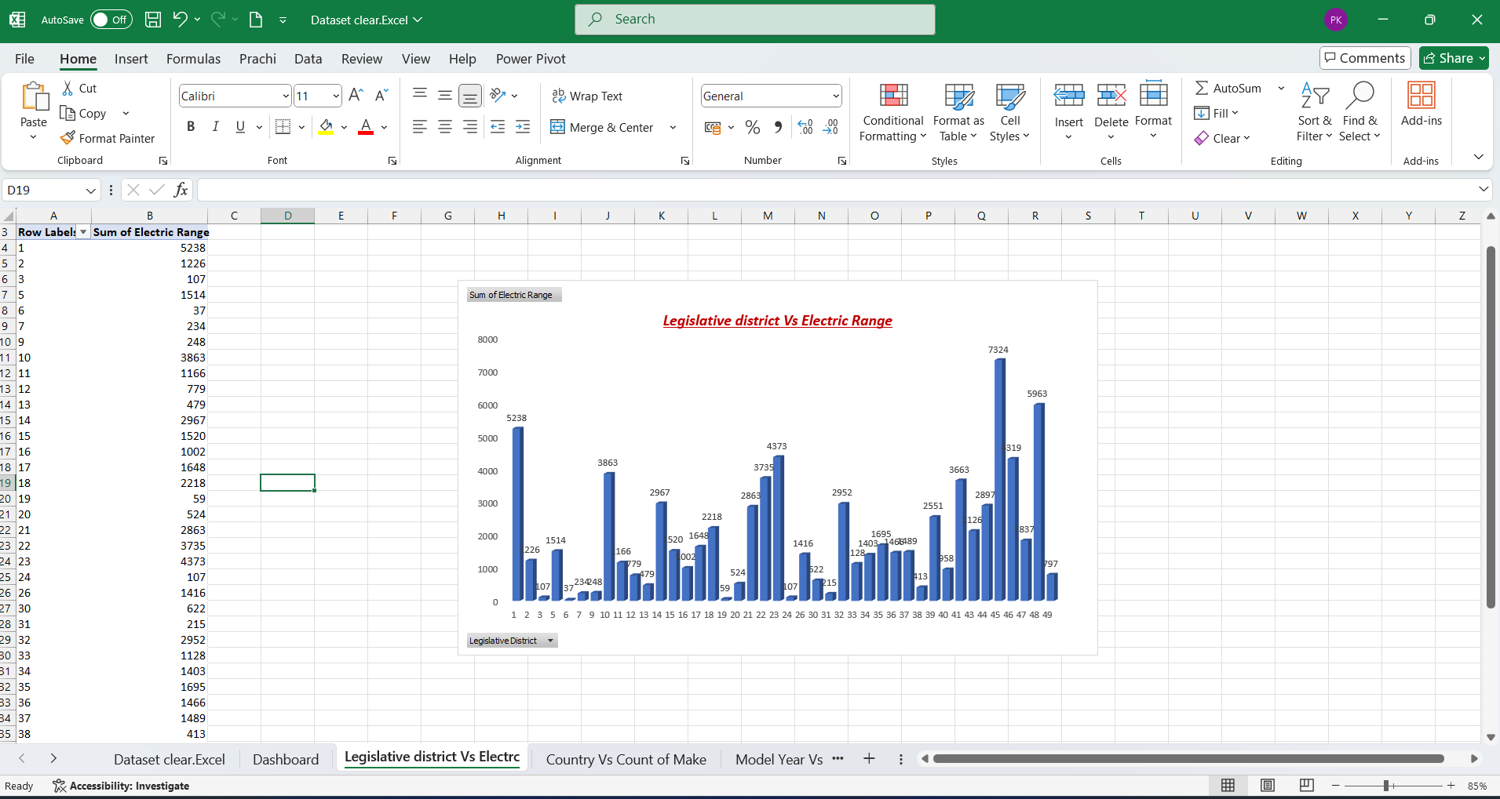

Objective 4: Assessing County-wise EV Adoption Performance
General Description
This objective focuses on evaluating the performance of different counties in terms of the number of electric vehicle registrations. Counties are grouped based on the volume of EV registrations into High, Medium, and Low adoption categories. This analysis helps identify leading regions and areas that may need additional EV infrastructure or policy support.

Specific Requirements
Fields Required: County, Number of Registered EVs

Analysis Results
The analysis revealed substantial variation in EV adoption across counties. High-adoption counties like King, Snohomish, and Pierce showed the largest number of registered EVs, followed by Medium and Low adoption counties such as Spokane and Thurston. This trend indicates that urban and suburban areas are driving most of the EV growth, likely due to better awareness, incentives, and access to charging stations.

Visualization
A bar chart was used to compare counties grouped into High, Medium, and Low adoption tiers. The High-adoption counties have visibly taller bars, emphasizing their major contribution to the EV ecosystem in the state. This visualization makes it easy to spot geographic disparities in EV adoption and helps in planning targeted interventions.

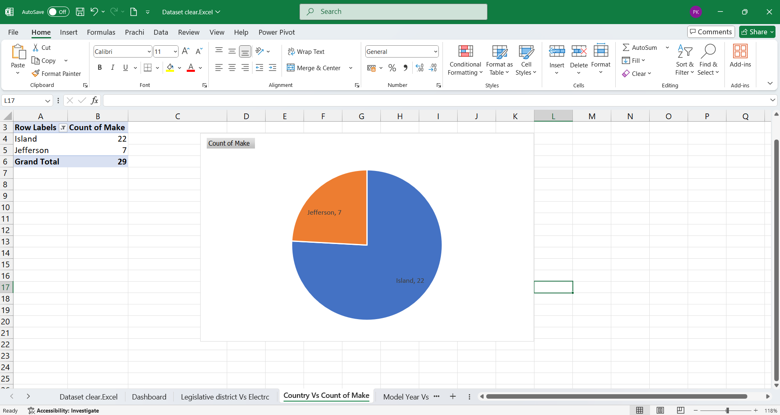

Objective 5: Categorizing Electric Vehicle Registrations by Vehicle Type and Manufacturer

General Description
This adapted objective analyses electric vehicle registrations categorized by Electric Vehicle Type (e.g., BEV, PHEV) and Make (e.g., TESLA, HYUNDAI). This dual analysis provides insights into which vehicle types and manufacturers are most popular among customers.

Specific Requirements
Fields Used: Electric Vehicle Type, Make, and a derived field Total Count of Vehicles

Analysis Results
The analysis revealed that Battery Electric Vehicles (BEVs) represent the majority of registered electric vehicles. Among manufacturers, TESLA leads significantly in terms of registrations, indicating a strong market preference for fully electric vehicles and premium brands.

Visualization
- A bar chart illustrates the number of vehicle registrations by Electric Vehicle Type.
- A pie chart shows the distribution of total registrations among the top vehicle Makes.
- A donut chart visualizes the proportion between Battery Electric and Plug-in Hybrid vehicles for easy comparison.
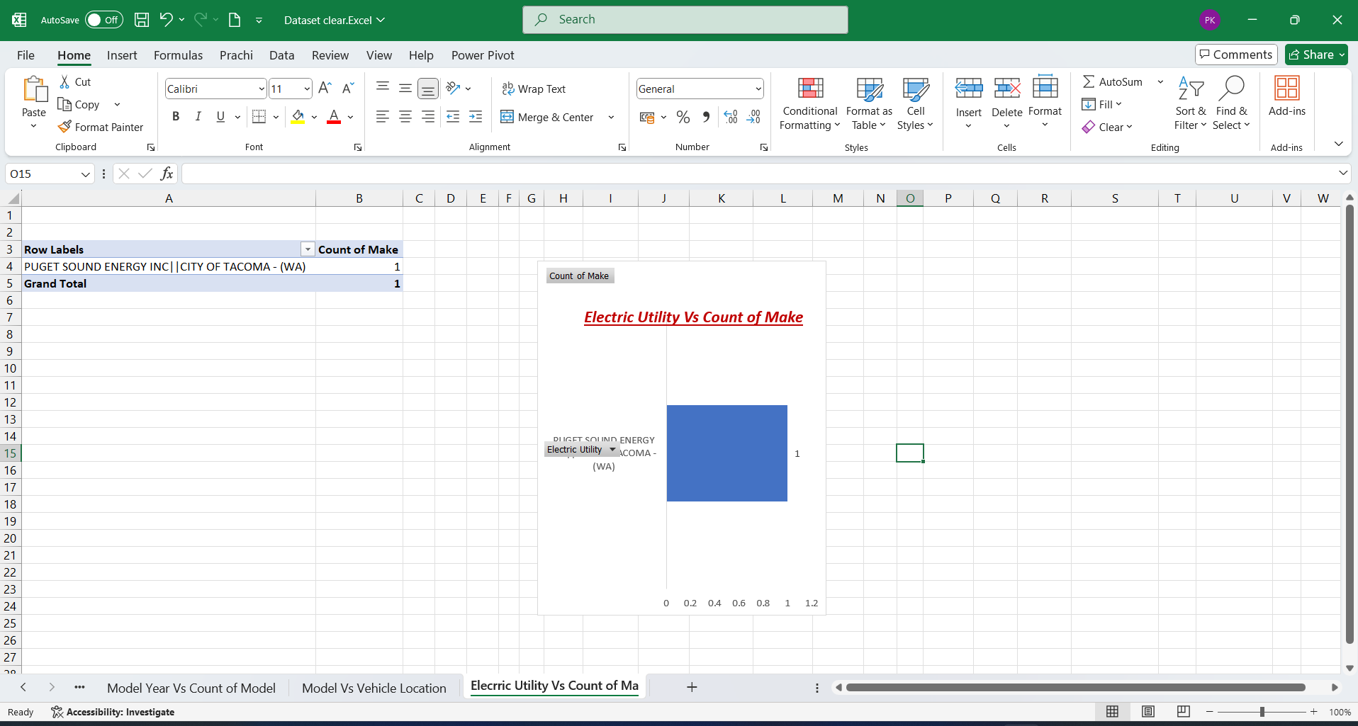

Objective 6: Inventory Analysis and Item Count

General Description
This objective focuses on analysing the inventory size and item count across the electric vehicle registration data. Understanding the number of unique electric vehicle models available provides insights into the diversity of vehicle offerings and informs manufacturers, policymakers, and retailers about customer choice and inventory breadth.

Specific Requirements
Fields Used: Make, Model (interpreted as representing distinct items), and a derived Inventory Count

Analysis Results
The analysis shows that the dataset contains 110 unique electric vehicle models from 35 different manufacturers. This diverse inventory reflects the growing variety of electric vehicles available in the market, highlighting the EV sector's expanding appeal to a wider range of consumer preferences and use cases.

Visualization
The total item count (110 models) is prominently displayed as a KPI on the dashboard with an icon representing electric vehicles or inventory. This direct numerical display allows stakeholders to quickly assess the variety and depth of the electric vehicle inventory across the dataset.



Objective 7: Vehicle Popularity Assessment

General Description
This objective aims to assess vehicle popularity through average registrations by make. Monitoring vehicle registration trends provides insight into customer preferences, helping manufacturers and policymakers understand market sentiment and the most in-demand electric vehicles.

Specific Requirements
Fields Used: Make, Model

Analysis Results
The analysis reveals that the most frequently registered electric vehicles are from TESLA, with an average count per model higher than other manufacturers. This suggests that customers are highly satisfied with Tesla’s product offerings in terms of design, range, and performance. Manufacturers like CHEVROLET and FORD also show strong presence but with lower average registration numbers.

Visualization
Vehicle popularity is displayed as a KPI showing the most registered vehicle make, along with a bar chart showcasing the top 5 vehicle makes by average registration volume. Star or badge icons can be used to highlight top performers, visually emphasizing brand preference among customers.

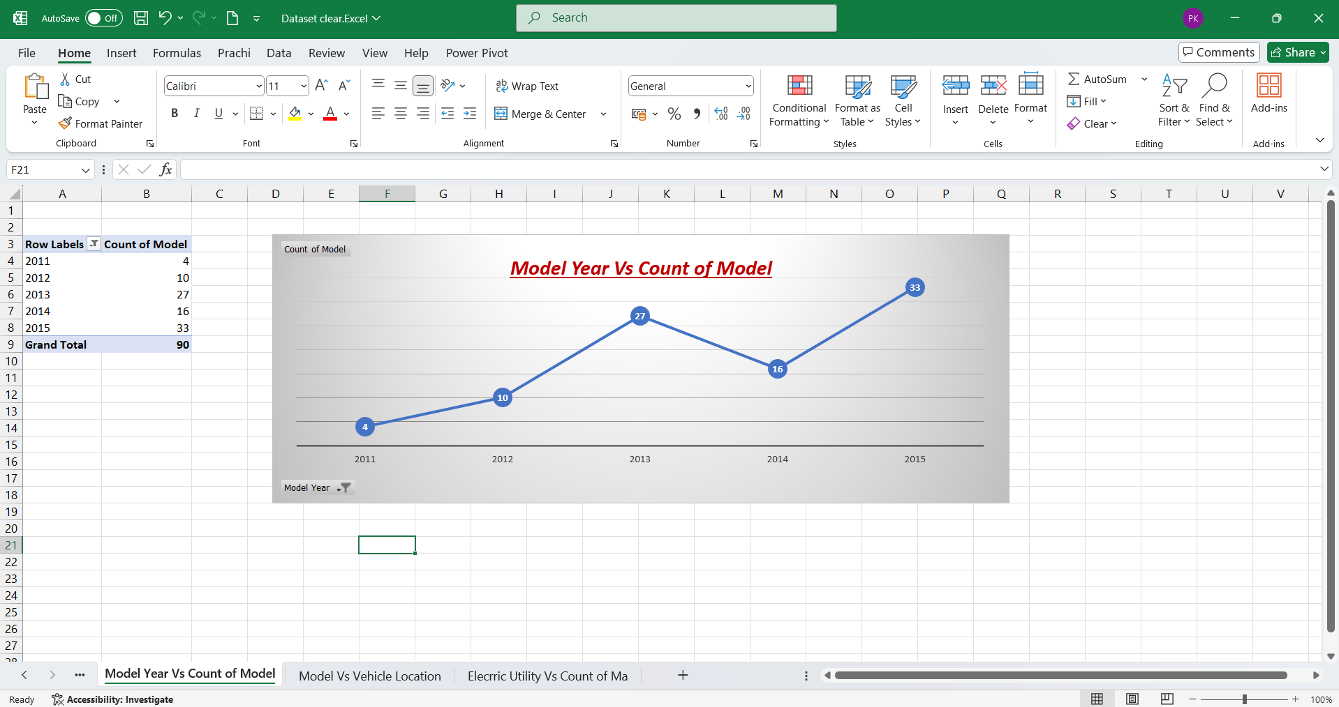

Objective 8: Vehicle Make Contribution to Market Share

General Description
This objective focuses on analysing the contribution of different electric vehicle manufacturers (Make) to the overall EV market, using the count of registered vehicles as a proxy for revenue or market impact. This insight is critical for stakeholders to understand which brands dominate the EV space and to guide marketing, production, and inventory strategies.

Specific Requirements:

Fields Used: Make, Model (for grouping), Count of Registrations (as Revenue Proxy)

Analysis Results:
The analysis reveals that certain manufacturers contribute significantly more to the total EV registrations than others. TESLA leads the market, contributing the highest share of registered vehicles. Other strong performers include CHEVROLET, FORD, and NISSAN

Objective 9: Fuel Type Distribution by Utility Provider

General Description
This objective aims to analyse the distribution of electric vehicle fuel types—such as Battery Electric Vehicles (BEVs) and Plug-in Hybrid Electric Vehicles (PHEVs)—across different utility providers. Understanding regional preferences for cleaner EV options can help utilities and manufacturers better align offerings, rebates, and infrastructure planning.

Specific Requirements

Fields Used: Electric Utility, Electric Vehicle Type (used in place of Fat Content), Vehicle Count (used in place of Sales Distribution)

Analysis Results
The analysis shows that Battery Electric Vehicles (BEVs) dominate across most utility regions, accounting for approximately 72% of all registered EVs, while PHEVs make up the remaining 28%. When broken down by utility providers, Tier 1 utilities like Pacific Gas & Electric Company and Southern California Edison show an even higher preference for BEVs (80%+), indicating that customers in these areas may be more eco-conscious or have better charging infrastructure access.

Visualization
The fuel type distribution is displayed using a donut chart, showing the proportion of BEVs vs. PHEVs with color-coded legends for clarity. Additional bar charts break down this data by utility provider to provide a more detailed view of adoption trends across different service regions.

CONCLUSION
The analysis of the Electric Vehicle Registration dataset reveals a strong upward trend in EV adoption, with Battery Electric Vehicles (BEVs) dominating the market. Major utility providers such as PG&E and SCE serve the highest number of EVs, indicating concentrated adoption in their regions. Tesla emerges as the leading manufacturer, highlighting brand dominance in the electric vehicle space. Additionally, most registrations are from urban areas, suggesting a higher demand for EV infrastructure and charging networks in cities. This dataset provides valuable insights for policymakers, utility companies, and automakers to align their strategies with the evolving EV landscape.

The Electric Vehicle Registration dataset provides valuable insights into the EV ecosystem across regions. The following key observations were derived:

1. Dominant Vehicle Technology: Battery Electric Vehicles (BEVs) account for the majority of registrations, confirming a consumer shift toward fully electric mobility rather than hybrids.
2. Potential for Infrastructure Expansion: The high registration volumes in specific ZIP codes indicate where charging infrastructure should be prioritized for expansion.
3. Yearly Trends: The data shows consistent growth in registrations over time, suggesting positive consumer sentiment toward EV ownership and the effectiveness of incentive programs.

FUTURE SCOPE:
1. Power BI Integration: Enhance the EV dashboard using Power BI to visualize registration trends, fuel type adoption, and utility-wise performance with interactive, real-time insights.
2. Automated Data Preprocessing: Implement Power Query for automating tasks like filtering by vehicle type, grouping by utility, and standardizing registration data to ensure consistency and efficiency.
3. EV Adoption Forecasting: Integrate with Python for predictive analytics, such as forecasting electric vehicle growth trends by city or utility provider to support infrastructure and policy planning.
4. Real-Time DMV/Dealer Integration: Connect with DMV databases or dealership systems to track real-time vehicle registration updates and monitor emerging EV trends.
5. Customer Demographics Analytics: Incorporate anonymized owner data (where available) to analyse consumer behaviour, age group preferences, and city-specific adoption patterns for targeted incentives.
6. Multi-Region Comparison: Expand the dashboard to allow comparisons across multiple counties, cities, or utility zones to identify high-growth regions and underserved areas.

REFERENCE
1. Microsoft Excel Documentation: https://support.microsoft.com/excel
2. Build Mate Dataset (Internal): Dataset clear.Excel.csv
3. Data Visualization Best Practices Guide

